Http vs Https
HTTP (Hypertext Transfer Protocol) and HTTPS (Hypertext Transfer Protocol Secure) are two protocols used for communication over the internet. The main difference between them lies in the level of security provided for data transmission.
HTTP is the standard protocol used for transmitting data over the web. It operates on top of TCP/IP (Transmission Control Protocol/Internet Protocol) and is typically used for accessing websites, transferring data, and retrieving resources such as HTML pages, images, videos, etc. HTTP uses port 80 for communication.
On the other hand, HTTPS is the secure version of HTTP that uses encryption to protect the data transmitted between a user's browser and the website. It adds an additional layer of security by using SSL/TLS (Secure Sockets Layer/Transport Layer Security) protocols to encrypt the data. HTTPS operates on top of HTTP, providing a secure connection over the internet. It uses port 443 for communication.
The encryption provided by HTTPS ensures that the data exchanged between the user and the website is secure and cannot be intercepted or tampered with by unauthorized parties. It prevents attackers from eavesdropping on sensitive information such as login credentials, credit card numbers, or personal data.
Here are a couple of examples to illustrate the difference:

1. HTTP:
Let's say you visit a non-secure website using HTTP, such as http://example.com. When you enter data on that website, such as filling out a form with your name and email address, the data is transmitted in plain text. If someone with malicious intent intercepts the communication, they can easily read and capture the data.
2. HTTPS:
Now, consider a secure website that uses HTTPS, such as https://example.com. When you visit this website and enter your data in a form, the information is encrypted before being transmitted. This encryption ensures that even if someone intercepts the data, they won't be able to understand it without the encryption key. HTTPS provides a secure channel for transmitting sensitive information.
In summary, while HTTP sends data in plain text, HTTPS encrypts the data, ensuring a secure and private communication channel between the user's browser and the website.
https://www.keyfactor.com/blog/http-vs-https-whats-the-difference/
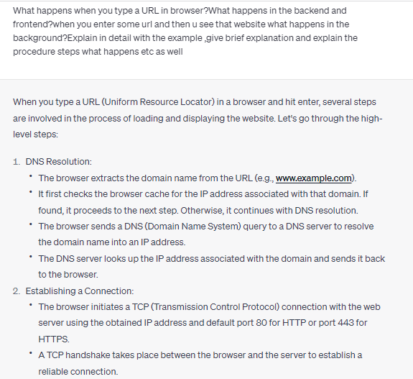
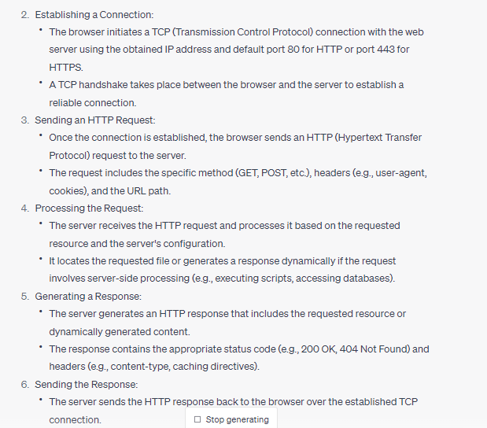
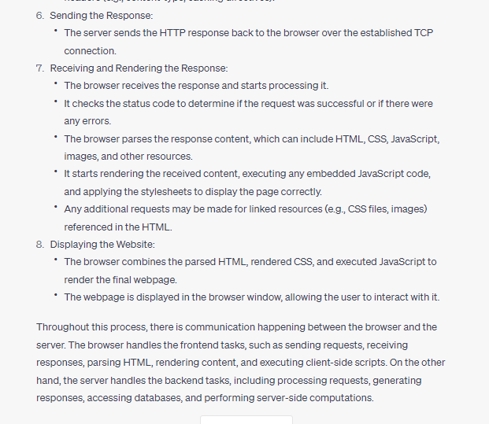
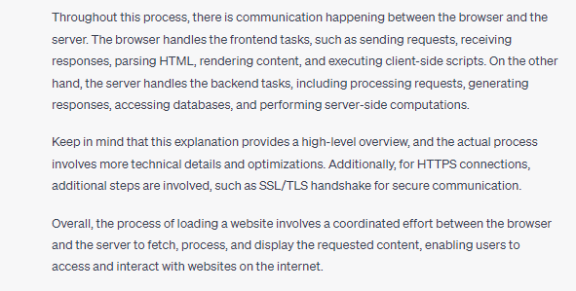
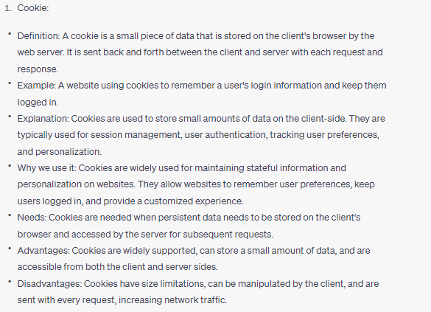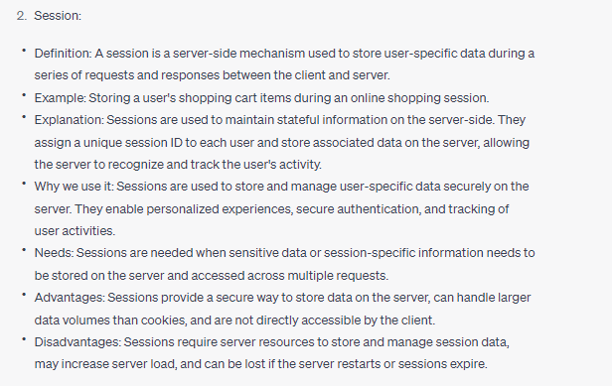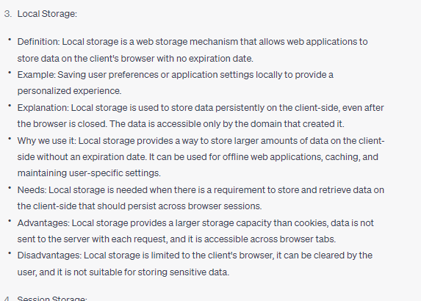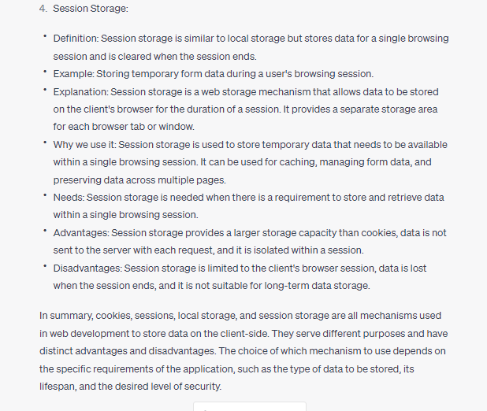https://www.youtube.com/watch?v=f54I61Apmxs
Jaisy hi browser bnd kia sessionstorage ma sa data delete pr local storage ma sa nahi hota.Sessions ka use hum ziada login page pr krty yani jb user login krta ha tu uski ek unique session id create ho jati ha jo server generate krta jisko hum local storage ma store kr skty. logout hony pr session ko delete kr dia jata ha.Localstorage ma hum mostly store krty hain ka user konsy pages visit kr raha ha ya usny language preference konsi select ki etc taky uska interest dekh kr ussko usi type ki chezain suggest recommend krain hum jaisy e-commerce website ma hota ha.
What is Mvc Architecture
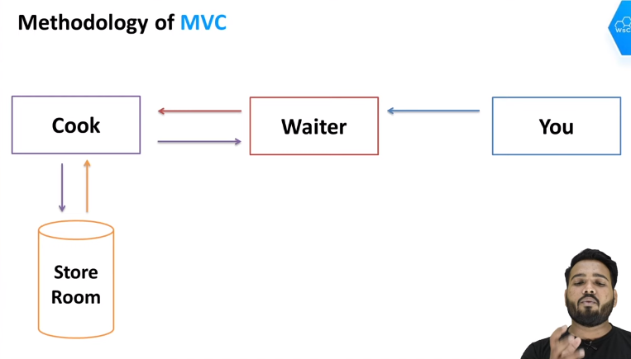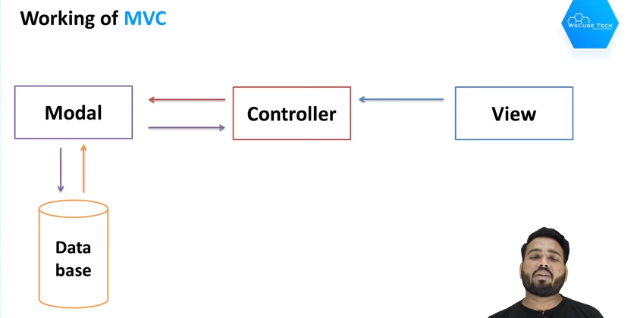
Bussiness logic lagany ka kam controller ka hota ha.
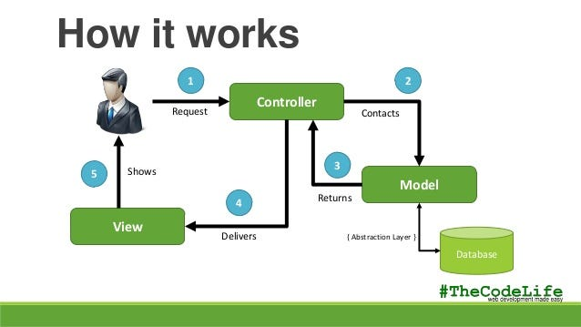

What are HTTP Status Codes
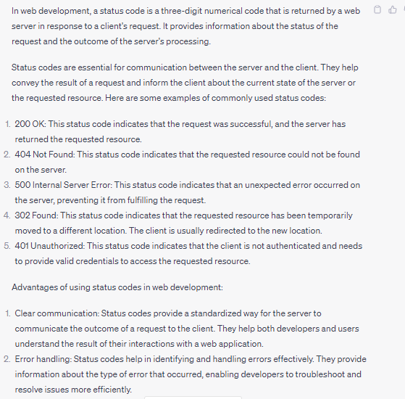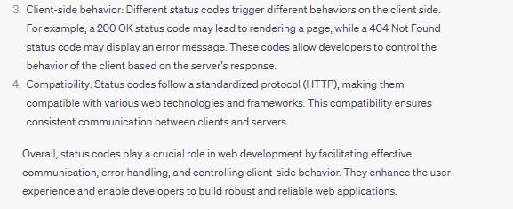
Status codes are divided into 5 groups
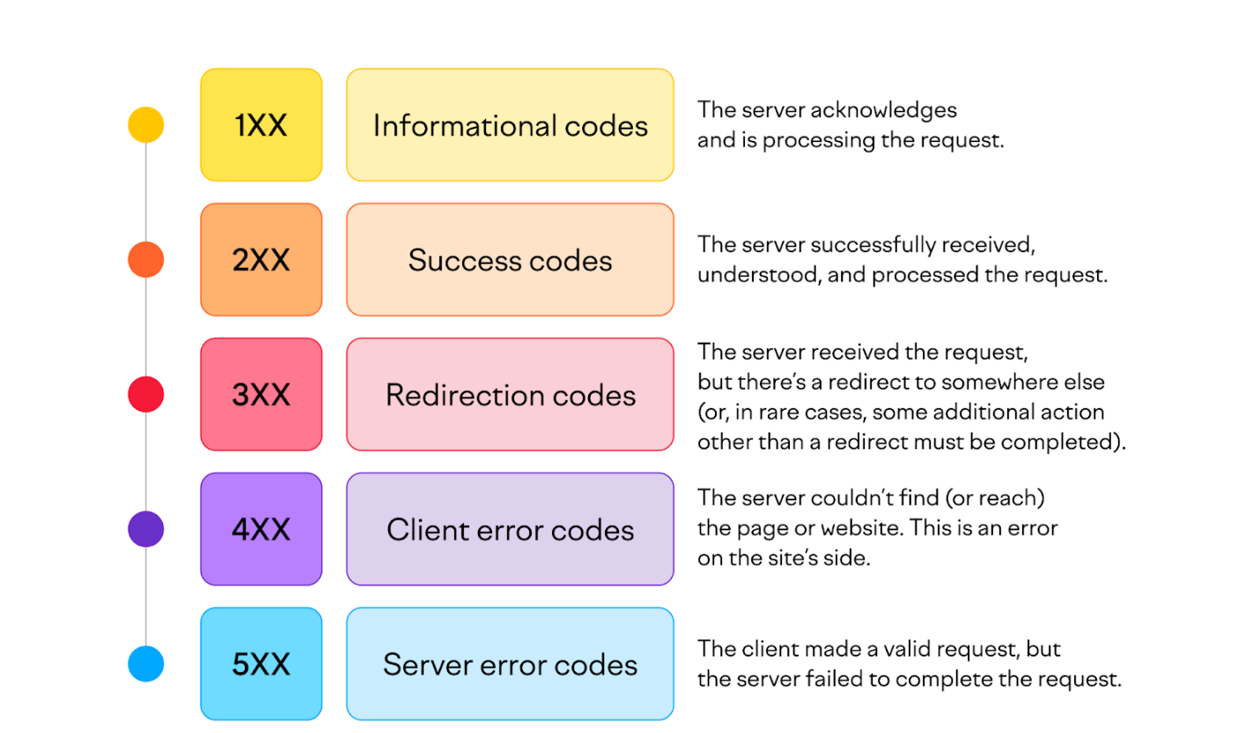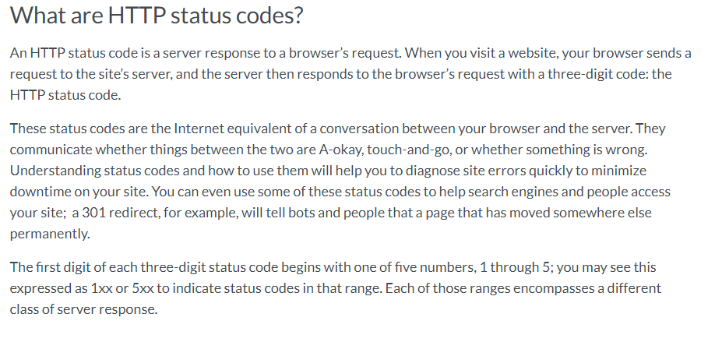
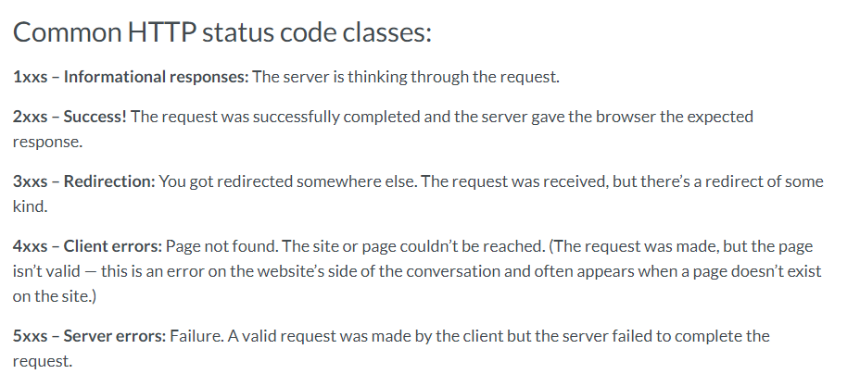
What is 404 status code means?
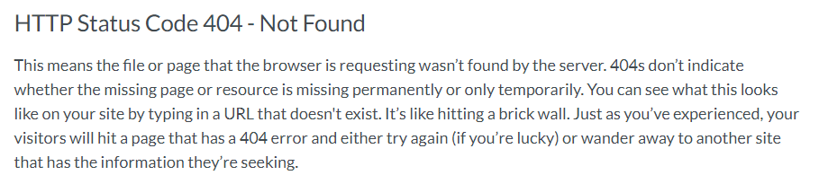
Application Server
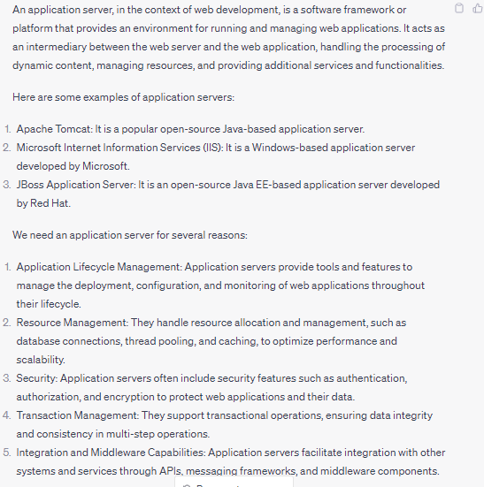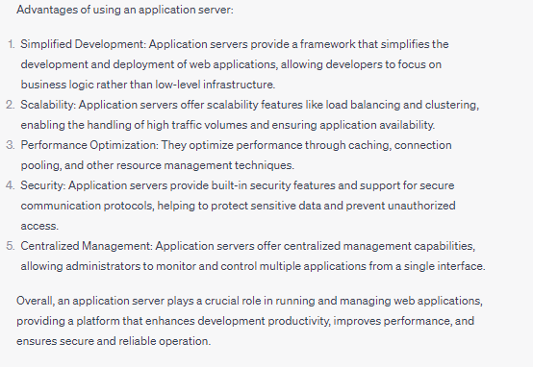
Application vs Web Server
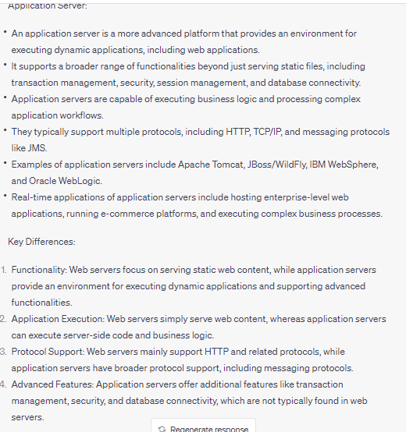
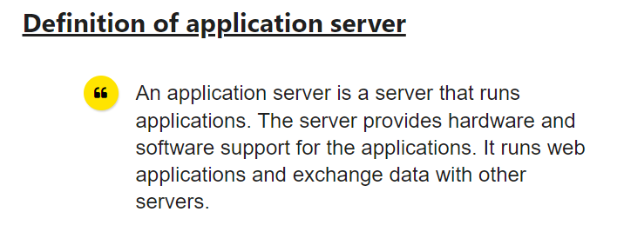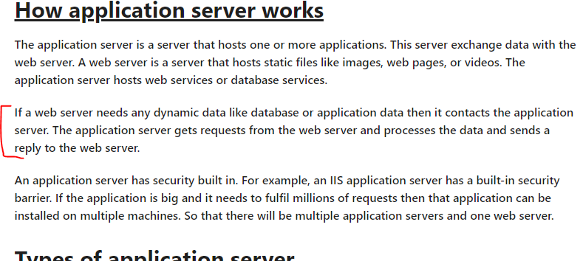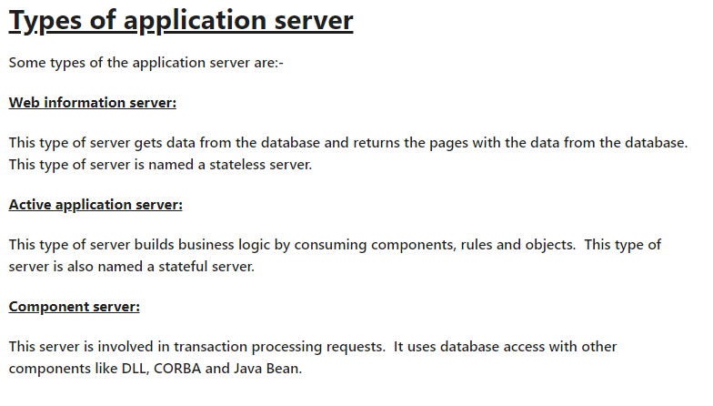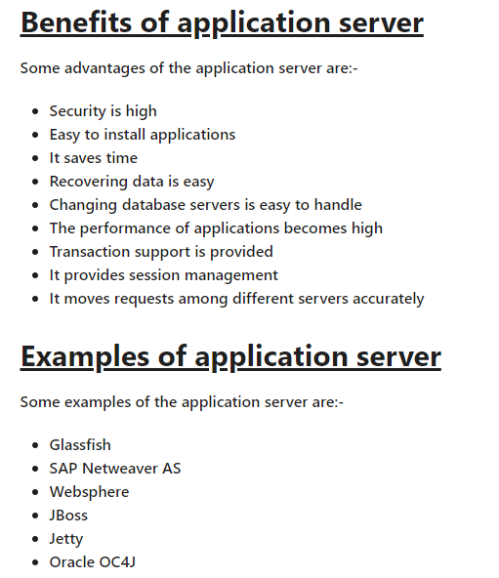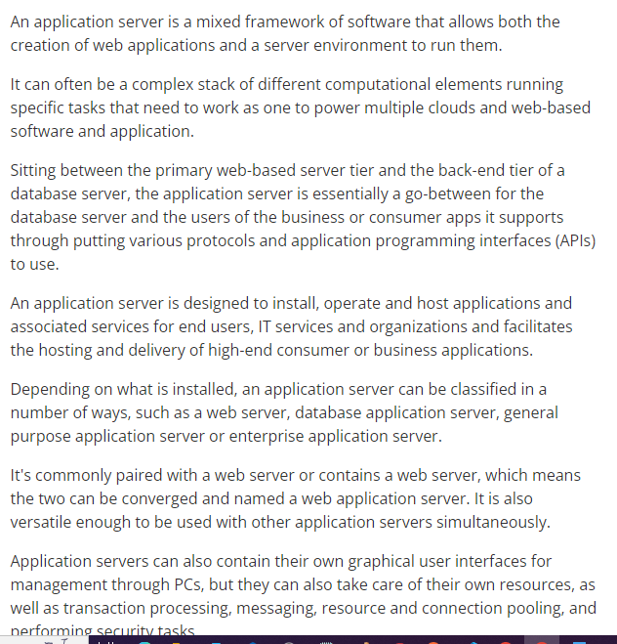

Framework vs library vs package vs module

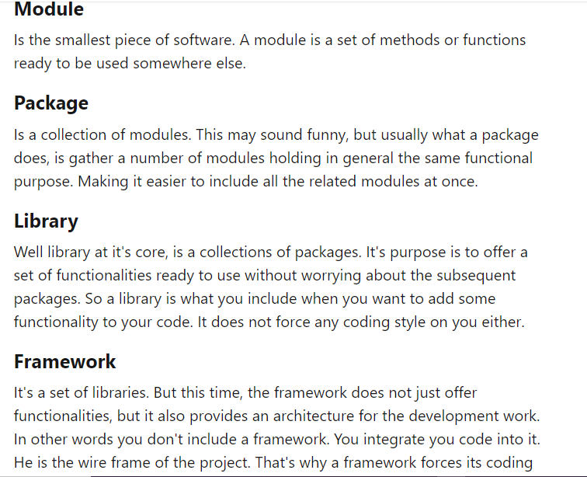
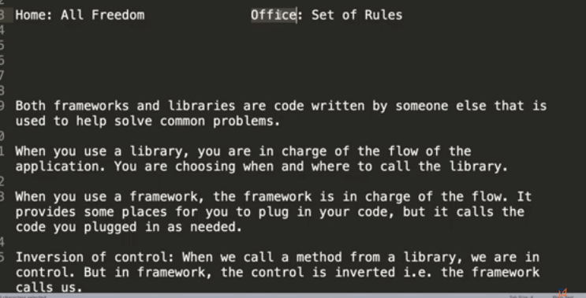jaisy jquery ek library ha usmy hum khud call krty hain methods ko msln date hamain current chahiay tu hum sird date ka function call krty hain jahan mrzi tu hum call kr rahy ye library ha.Jbky Framework jasy bootstrap ha msln humny alert lagana tu hamain alert-primary dena ho ga as class agr nahi krain koi apna likhna chahty tu wo alag bt pr krna aisy hi ho ga.
https://youtu.be/V961cMZKB5M
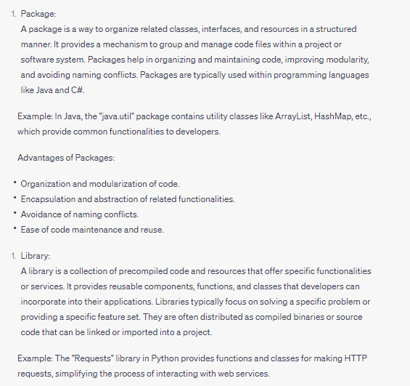
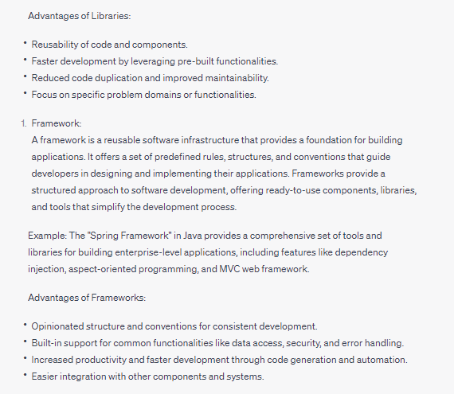
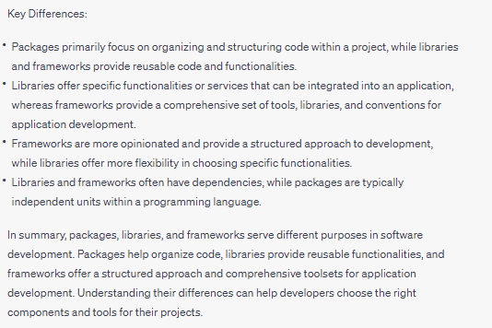
https://www.youtube.com/watch?v=973cyV6us9s
https://www.geeksforgeeks.org/software-framework-vs-library/

